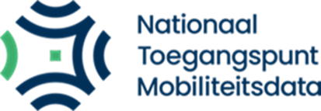 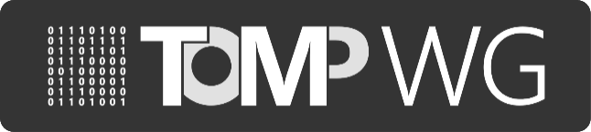

**Report of MaaS-API working group**

*22/02/2023, session #73*

*10:00h-12:00h, Teleconference*

*Attended by (14)*:

Tu-Tho Thai (MobilityData) - Chair

Eddy Borremans (Nazza)

Edwin van den Belt (Dat.mobility)

Gerrit Saey (Pitane)

Ayse Öcal (NTM)

Paul Theyskens (MaaS Alliance)

Lars Grevelink (Mobian)

Alberto Capponi (Nordcom)

Bram Seeuws (Vervoerregio Amsterdam)

Feisser.Darren (ESB)

Kristian F.L Amlie (Bouvet Norge AS)

Marijn Roverts (Next Urban Mobility)

Stefan bollars (Innovactory)

**Summary of decision points & feedback from actions from previous working session** The following tasks were defined during the previous sessions:

|  |  |  |  |  |
| --- | --- | --- | --- | --- |
| *No.* | *Context* | *Tasks* | *Status* | *Due date* |
| 70.1 | Involve car-sharing operators and discuss  progress on implementing  TOMP-API | Bram will do his best to provide more details about which car sharing operators are interested in using TOMP-API. Also, an update about which are using a third party provider for their IT solution or the mobile app. | To do | No deadline |
| 73.1 | Working group 6 made a governance (funding, marketing, organizational) proposal. This proposal needs feedback of the group | The proposal will be sent to everybody. All feedback is welcome. In the next meeting the feedback will be discussed.  Also, the WT6 will detail benefits for prospective sponsors and members | To do | Next meeting |
| 71.2 | Impact and  implementation of eIDAS 2.0 | **Edwin** will propose the SC to set up a Taskforce.  Update: SC has been contacted, Edwin will make an appointment for a follow-up. And this will remain a point for the next meeting. This will be continued for the first few months | To do | Next meeting & following |
| 73.1 | Use case driven communication. Edwin gave a presentation about a use case driven working method. | Everybody can send Eddy (trough Slack or email) some use cases of issues that they have encountered, or people asking us about the implementation of the TOMP-API. | To do | Next Meeting & following |

# Progress on governance structure

The CAB is the link between the working groups and the Strategic Committee. We are happy to announce that Eddy Borremans will be the representative of the TOMP in the CAB.

For now, the national and international governance is mixed. This is a temporary situation and future developments should make the governance and roles clearer.

# Supporting implementation

# *Use case driven communication*

The goal of Edwin’s use case driven communication is to make the TOMP-API as accessible as possible by describing use cases. Everyone agreed that this would be helpful.

Action: WT2 wants to work with use cases. We will discuss the use cases that Eddy will receive. WT4 will make a framework (a template) to make it more consistent.

Edwin and Paul will connect each other, where they can help each other with those use cases.

*Interaction car-sharing operators*

Bram from autodelen.net indicated that the biggest barriers to implementing the TOMP are not technical problems. The biggest problem is often capacity especially for local smaller operators. For them, the revenues and benefits of implementation are not clear enough.

Action: Bram will give an overview on what platform the operators use to Edwin and Eddy.

# Update WT1 Technical issues

• The next meeting the choice should be made between version 2.o and 1.5

Action: Edwin will gather the input of the proposal of the impact of v2.0, The issue system will be used get input for the proposal.

* There are different registrations for scooters/bikes, the TOMP-API doesn’t cover those actions (unlocking, starting a scooter, opening the helmet tray).

Action: Edwin will double-check to see if this problem is on the operator side or on the MaaS operators side. If the latter, TOMP-API will have to be revisited soon.

# Update WT2 Reference implementation and certification

• Still working on the implementation with APDS.

* Strong interest to use TOMP-API to interconnect car operators with each other instead of via an intermediate platform (MaaS operators). Eddy will put this on the agenda of the next meeting.
* Action: Kristian will send a high-level use case to Eddy
* WT2 will give more details about NAPCORE, Markus will attempt the next meeting.

# Update WT3/4 Standards and communication

* TOMP-WG can supply some content for the NTM newsletter. The WT will work on some content.
* A blogpost with a follow up about the standards will be uploaded soon.
* In March the TOMP-API will be represented at the Autonomy conference in Paris.

# Update WT6 Governance

• Working on a governance structure: to get more international stakeholders. It is moving to the right direction. The WT6 group presented a proposal. Everybody can give feedback and this will be discussed at the next general meeting.

# Next online meeting (working session #74) will be Wednesday 29 February 2023.